**Complete your listing details below**

Top of Form

**General**

**Title / Company Name / Therapist Name**

Mr Gordon Young

**Company / Therapist Tagline (optional)**

Don’t waste another day

**Bio and clinic description (this will help potential clients understand why they should book with you)**

Bottom of Form

Gordon Young is the director and lead trainer of the Institute of Applied Psychology and the creator of Sydney Hypnotherapists. Gordon is an internationally recognized name in the world of NLP and Hypnotherapy. He is considered by many to be Australia’s leading NLP Trainer and Hypnotherapist having studied in Australia and in the United States with both the creators of NLP and the leaders in the field of Hypnotherapy. Gordon trained at the prestigious Milton Erickson Foundation in Phoenix Arizona, the absolute pinnacle of training in modern hypnosis.

Gordon is the former President of the Australian Society of Clinical Hypnotherapists, Editor of the *Australian Journal of Clinical Hypnotherapy and Hypnosis*, and the Chair of the Australian Board of Neuro-Linguistic Programming. Moreover, he is not just a therapist. Gordian teaches a unique advanced form of hypnosis known as Strategic Hypnosis and is the creator of the Gordian Pillars of Psychotherapy.

Additionally, Gordon supervises over 60 psychologists, counsellors, and hypnotherapists, guiding them through difficult cases behind the scenes.

**Client Focus**

**Types of (Select at least 1 option)**

Strategic Psychotherapy,   
Clinical Hypnotherapy,   
Ericksonian Hypnosis,   
NLP Psychotherapy,   
Strategic Coaching

**Conditions Treated (Maximum 16 choices only)**

Abandonment



Addictions



Agoraphobia



Anger



Anxiety



Attitude Adjustment



Bed Wetting



Behaviour Modification



Career Success



Change Habits



Child Birth



Communication



Concentration



Cravings



Creativity



Depression



Exam Anxiety



Fear of Flying



Fear of Rejection



Forgiveness



Frustration



Gagging



Gambling



Goal-setting



Grief



Guilt



Hair Twisting



Headaches



Helplessness



Hypochondria



Immune System Issues



Impotency



Indecision



Irrational Thoughts



Irritability



Jealousy



Lack of Purpose



Lack of Direction



Lower Blood Pressure



Memory Issues



Nail Biting



Obsessive-Compulsiveness



Overeating



Pain Management



Parenting Struggles



Panic Attacks



Perfectionism



Performance Anxiety



Phobias



Physical Dysfunction



Post Operative Healing



Premature Ejaculation



Procrastination



Public Speaking



Relationship Improvement



Self-Criticism/Lack of Confidence



Self-Sabotage



Trust Issues



Workplace Stress



**Client Session Format (Select a minimum of 1 option)**

**Age Specialty (Select a minimum of 1 option)**

**Demographic Specialty**

Gay/Lesbian



Bisexual/Transgender



Military/Veterans



People with Disabilities



Women



Men



Teenagers



Children 5-12



**Treatment Approach (Write 50-200 words on the types of techniques that you would be using with clients)**

My treatment approach is simple. The problems you face are not because of you. They are a series of habituated patterns of thinking and responding that you have learned as a child. The good news is they can be changed, and hypnosis or trancelike interventions are arguably the best tools to facilitate this.

However, where most of these approaches focus on relaxation skills, I will look to change your patterns of response. If you present with stress or anxiety, most approaches will probably get you to imagine yourself relaxing in a cool forest or get you to focus on being present. Nice, but how does this protect you into the future? If you are going to diffuse your anxiety long term you need to learn how to respond differently to the perceived threats.

We need to review the way you assess risk. Anxious people see risk where others don't. We might need to help you not take things so personally. We need to make you Teflon. Whatever we do, we need to change the way you operate, not just calm you down. Most help you in the moment. I am going to give you the skills to live a better life.

**About the Therapist**

**Contact Name**

Gordon Young

**Phone Number**

1300 380 681

**Contact Email**   
[Gordon@iap.edu.au](mailto:Gordon@iap.edu.au)

**Website ( Put the complete URL e.g. https://iap.edu.au/findapractitioner/ )**

**(optional)**

<http://sydneyhypnotherapists.com.au>

**Location**

Lock Pin Location

Enter coordinates manually



**Prepare Listing Images**

Profile Default Image (226 x 245 px)   
Maximum file size: 3 MB.



Cover Image (1260 x 400 px) (optional)

Maximum file size: 3 MB.



Gallery Images (optional)

Maximum file size: 3 MB.

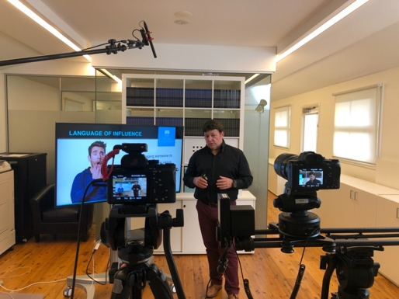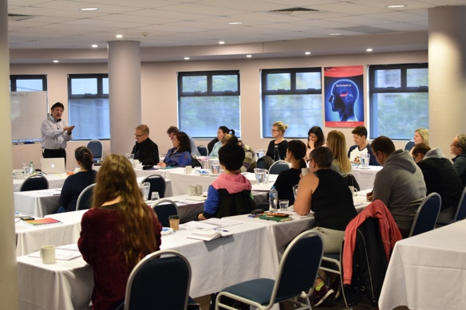

**Therapist Practice Details**

**License State:**

New South Wales

**Practicing since**

June 2003

**Company or Individual name**

Institute of Applied Psychology T/A Sydney Hypnotherapists

**Where did you train?**

Macquarie University, Milton H Erickson Foundation

**Qualifications**

B.A. (Hons) Dip. Ed, Dip. CHSP.

**Associations (optional)**

Australian Hypnotherapists Association (AHA)



Australian Society of Clinical Hypnotherapists (ASCH)



Australian Counselling Association (ACA)



Psychotherapists and Counsellors Federation of Australia (PACFA)



Australian Society Of Hypnosis (ASH)



Professional Clinical Hypnotherapists of Australia (PCHA)



Professional Hypnotherapists of Australia (PHA)



Australian Association of Clinical Hypnotherapy & Psychotherapy (AACHP)



Others



**Therapist Schedule**

**Work Hours**

* + [Mon](https://iap.edu.au/findapractitioner/add-listing/#day_Monday)
  + [Tue](https://iap.edu.au/findapractitioner/add-listing/#day_Tuesday)
  + [Wed](https://iap.edu.au/findapractitioner/add-listing/#day_Wednesday)
  + [Thu](https://iap.edu.au/findapractitioner/add-listing/#day_Thursday)
  + [Fri](https://iap.edu.au/findapractitioner/add-listing/#day_Friday)
  + [Sat](https://iap.edu.au/findapractitioner/add-listing/#day_Saturday)
  + [Sun](https://iap.edu.au/findapractitioner/add-listing/#day_Sunday)

Enter hours



Open all day



Closed all day



By appointment only



**Pricing Details**

**Price Range**

$250 - $400

**Health Fund or Medical Rebates Available**

Depends on Individual memberships or the holding of a Mental Health Plan

**Will You Offer Online Therapy?**

Online Sessions Available

**Social Networks**

**Social Networks (optional)**

**How to edit your listing**

Top of Form

**Step 1: When you are logged in already, click on My Account on top navigation dropdown under your email**

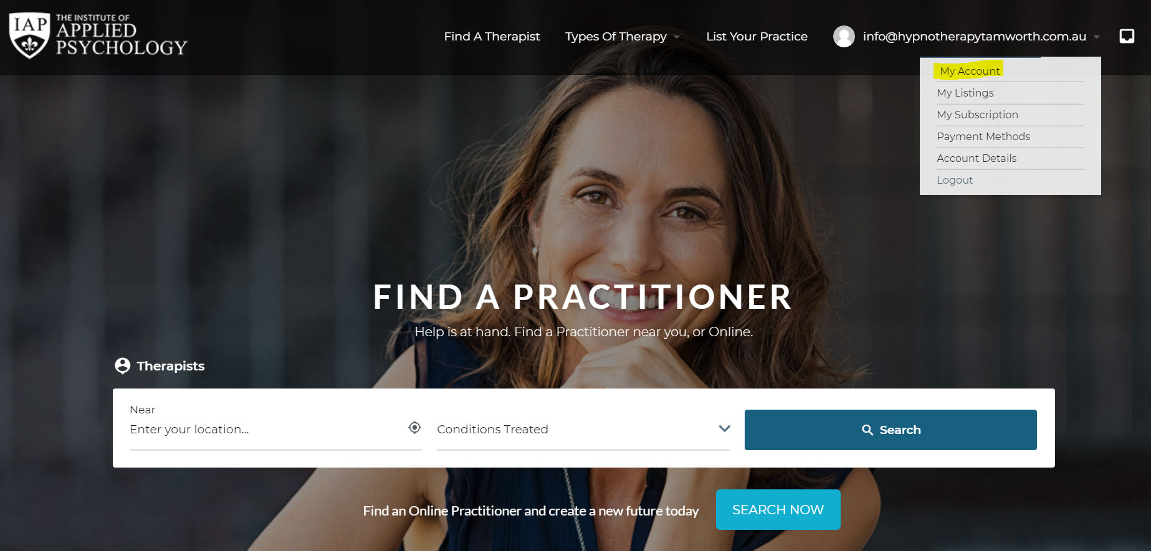

**Step 2: Click on My Listings Tab**

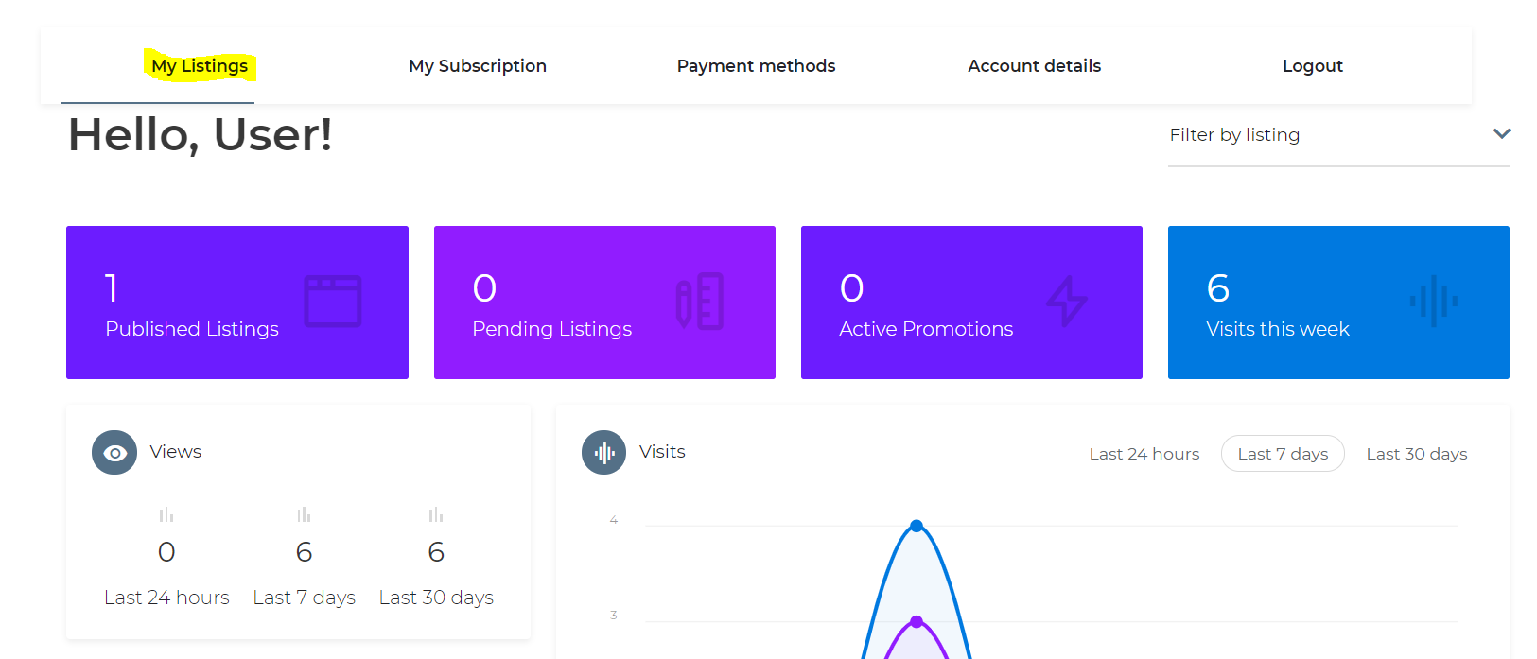

**Step 3: Click on Edit**

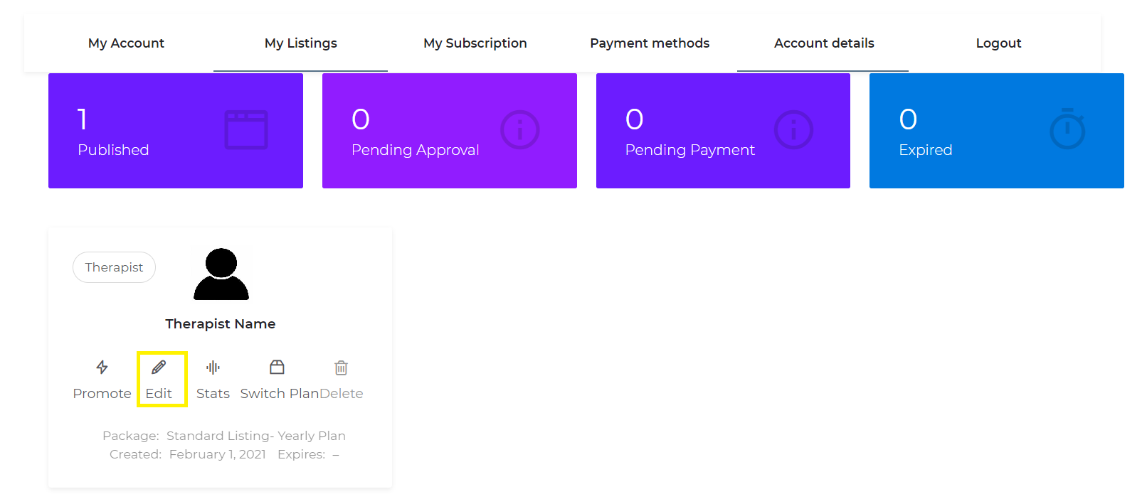

**Step 4: You may edit already and Save changes.**

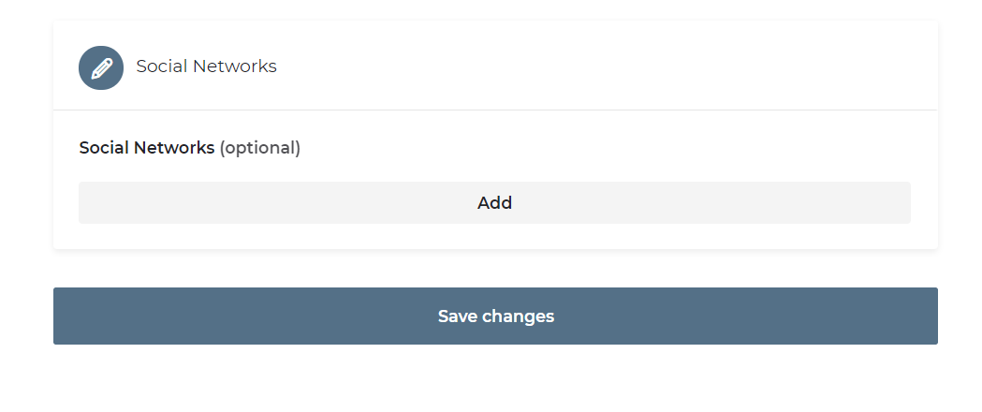

**And You’re done!**